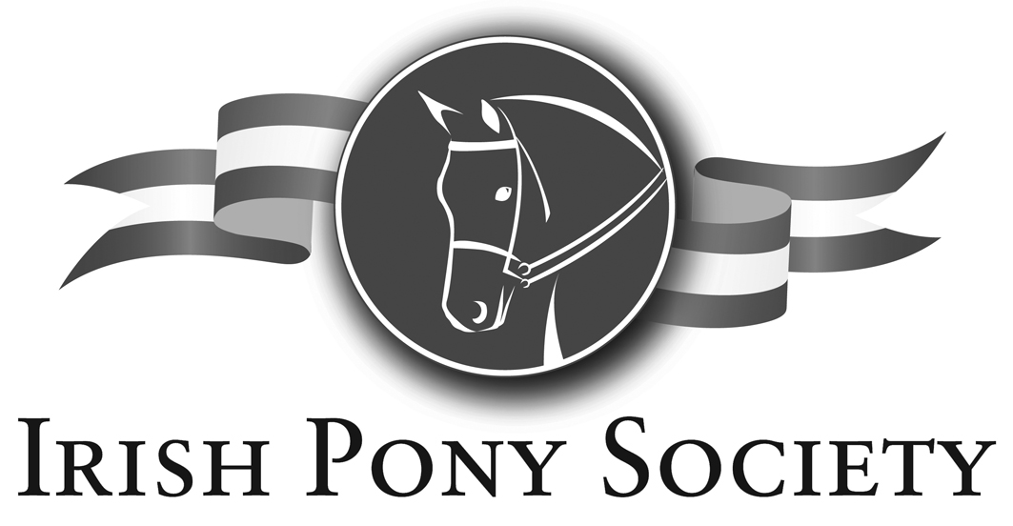

C/o Horse Sport Ireland, 1st Floor, Beech House, Millennium Park, Naas, Co Kildare

Tel: 00353-(0)45-854513 Fax: 00353-(0)45-850850
e-mail: irishponysociety@eircom.net website: www.irishponysociety.com

APPLICATION FOR OVERSEAS TRAVEL VISA

Owners Name :___________________________________________________________________

Address : ____________________________________________________________________

____________________________________________________________________

____________________________________________________________________

____________________________________________________________________

Current Membership Card No. : ______________________________

Pony Name : ______________________________________________________________

IPS Registration No. : ______________________________________________

Current Height : __________________________________________________

Date of Departure : ______________________________________

I agree to be bound by IPS rules and the IPS Code of Conduct at all times, including whilst competing overseas. I also undertake to ensure that all members of the party who travel with me will also adhere to IPS rules and the IPS Code of Conduct.

Signature of Owner : ______________________________________________

Date : _________________________________________

